**Oud, Jacobus Johannes Pieter (1890-1963)**

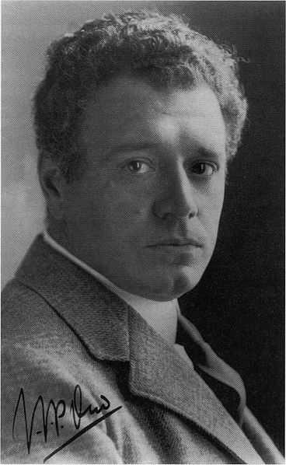

Photographic portrait of J.J.P. Oud.

<http://en.wikipedia.org/wiki/File:J.J.P._Oud.jpg>

J.J.P. Oud was a Dutch architect associated with the avant-garde movement known as DE STIJL. This group developed an elemental, abstract style based upon pure geometric forms and primary colours. As an architect, Oud was instrumental in extending the De Stijl aesthetic to three dimensional spaces; he thereby played a pioneering role in the development of Modernist architecture. His subsequent work was aligned with the austere, geometric mode known as the INTERNATIONAL STYLE.

Oud was born in Purmerend near Amsterdam, the son of a wine and tobacco merchant. He was educated in Amsterdam and at Delft Technical University. An early inspiration was the innovative Dutch architect H.P. BERLAGE, whose experiments with steel-frame construction helped to define modern architecture as the art of spatial enclosure and had a formative influence on the emerging MODERN MOVEMENT. In 1911 Oud worked for the architect Theodor Fischer in Munich. He subsequently worked with W.M. Dudok in Leiden and it was here in 1916 that he encountered the visionary artist, designer and theoretician THEO VAN DOESBURG.

Van Doesburg was developing a radical form of Neo-Platonic cubism in collaboration with the artist PIET MONDRIAN. This was disseminated via the journal *De Stijl*, which was launched in 1917. The title of the journal was also applied to the artists and designers who used it as a forum for their ideas. **Oud** became a chief proponent of De Stijl architecture, which stood in sharp contrast to the EXPRESSIONISM of the AMSTERDAM SCHOOL. His approach was articulated in theoretical projects for houses at Scheveningen (1917) and for a factory at Purmerend (1919). Among the first concrete expressions of his cubic style was the Villa Allegonda at Katwijk (1917), an ambitious design that achieved aesthetic balance by careful opposition of horizontal and vertical lines.

Oud designed several houses in collaboration with van Doesburg, who created colour schemes, stained glass and tiled floors in strict accord with De Stijl principles. A prime example is the De Vonk Holiday House in Noordwijkerhout, a relatively traditional building enlivened with mosaics of coloured brick and tiled floors. Oud’s major contribution to De Stijl architecture was the Café de Unie in Rotterdam (1924–27), where the asymmetrical façade evokes a Mondrian canvas. The building was destroyed in 1940, but Oud’s scheme was reconstructed in 1986 and provides a rare glimpse of a De Stijl environment.

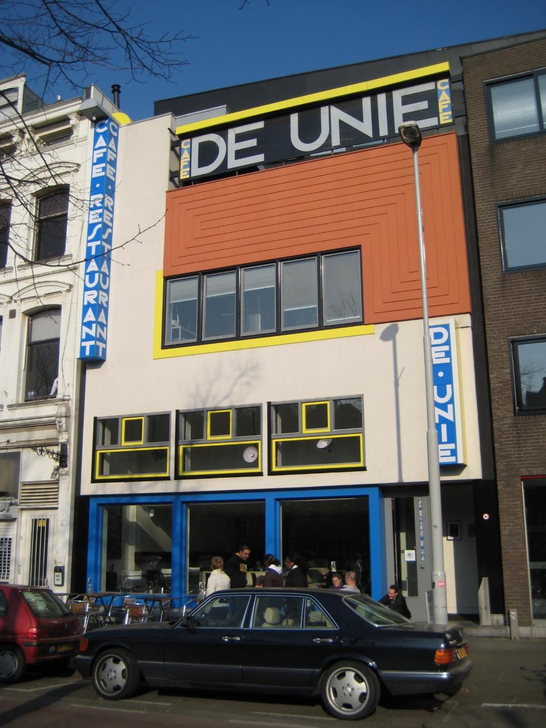

The reconstructed Café de Unie, Rotterdam.

<http://farm4.staticflickr.com/3428/3848157884_5887e5562f_o.jpg>

Despite his involvement with avant-garde figures, Oud was committed to socially-progressive design. He occupied the official post of Municipal Housing Architect for Rotterdam from 1918 to 1927. In this role he designed mass housing projects for workers at Spangen (1918), Hoek van Holland (1924–27) and Kiefhoek (1925-30). These designs were based on rational and inexpensive construction techniques, but also aimed to meet the psychological needs of the residents. He described this approach as ‘poetic functionalism’.

**In 1926 Oud** published the book Höllandische Architektur (Dutch Architecture), which established his international reputation. He was one of seventeen architects who contributed to the WEISSENHOFSEIDLUNG Exhibition held in Stuttgart in 1927. This was a housing estate designed to showcase the principles of Modernist architecture. Oud designed a terrace of two-storey houses, their plain white surfaces broken by horizontal strip windows. In 1932, Oud featured prominently in the International Style exhibition organised by PHILIP JOHNSON and Henry Russell-Hitchcock at the Museum of Modern Art in New York, which introduced European Modernism to the United States.

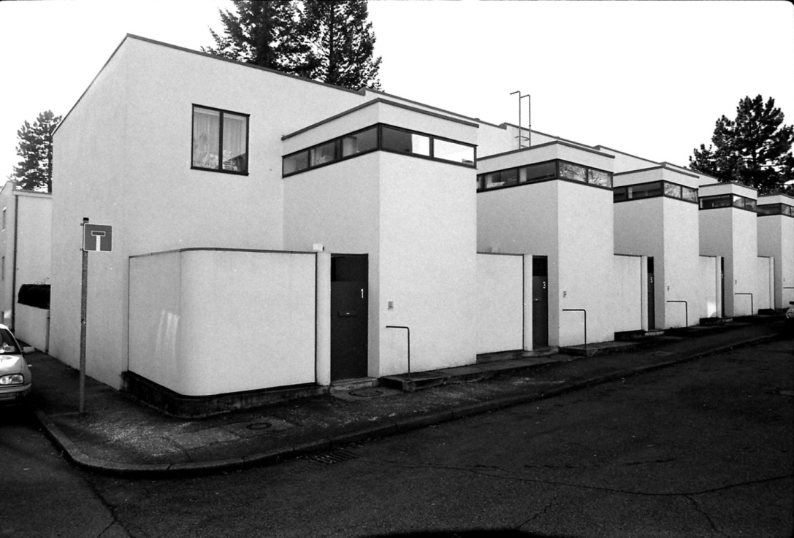

Prototypical Modernist housing designed by Oud at the Weissenhofseidlung Exhibition, Stuttgart, 1927.

<http://architetturainsostenibile.files.wordpress.com/2011/04/stocccardakarlsrue033-copy-e1303158297624.jpg>

After the Second World War, Oud gradually abandoned De Stijl principles and relaxed into a more playful mode. His Shell Building in The Hague (1938-42) drew criticism for betraying the uncompromising spirit of Modernism. Nevertheless, his later works, including the Bio Children’s Convalescent Home (1952–60) near Arnhem, demonstrated **Oud**’s command of rigorous geometric composition. Oud died in Wassenaar in 1963.

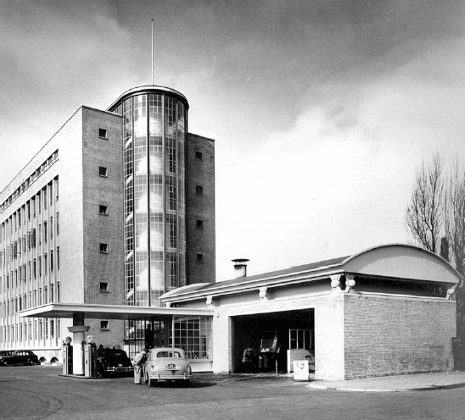

Shell Building, The Hague (1938-42), a more ornate form of Modernism.

<http://classconnection.s3.amazonaws.com/931/flashcards/21931/png/screen_shot_2011-05-07_at_9.54.27_pm1304820040097.png>

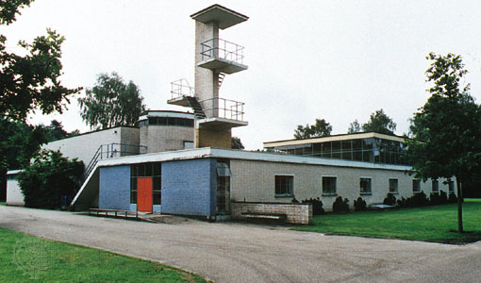

Bio Children’s Convalescent Home, Arnhem, 1952-60.

<http://media.web.britannica.com/eb-media/55/9755-004-98174026.jpg>

**List of works**

1917 Villa Allegonda, Katwijk aan Zee (with Harm Kamerlingh Onnes)

1917 De Vonk Holiday House, Noordwijkerhout (with Theo van Doesburg)

1918 Blocks I and V, workers’ housing, Spangen, Rotterdam

1920-21 Blocks I to IV and VI, workers’ housing, Tuschendijken, Rotterdam

1922 Garden Village, Oud-Mathenesse, Rotterdam

1925 Café de Unie, Rotterdam

1926-27 Workers’ Houses, Hoek of Holland

1927 Five houses, Weissenhofseidlung Exhibition, Stuttgart, Germany

1928-30 Kiefhoek Housing Development, Rotterdam

1938-48 Shell Building, The Hague

1942-57 Spaarbank, Rotterdam

1952-60 Bio Children’s Convalescent Home, Arnhem

1954-61 De Utrecht office building, Rotterdam

1956 National Monument, Amsterdam

**References and further reading**

Overy, P. (1991) *De Stijl: Art, Architecture, Design,* London: Thames & Hudson.

Stamm, G. (1984) *J.J.P. Oud: Bauten und Projekte, 1906 bis 1963.*Berlin:F. Kupferberg.

Taverne, E., Wagenaar, C., Vletter, M. and Broekhuizen, D. (eds.) (2001) *J.J.P. Oud: Poetic Functionalist 1890-1963, Complete Works*, Rotterdam: NAi publishers.

Troy, N.J. (1983) *The De Stijl Environment*, Cambridge, Mass.: MIT Press.

White, M. (2003) *De Stijl and Dutch Modernism.* Manchester: Manchester University Press.

**Michael Johnson**

**Northumbria University**